Balancing security and analytics

**The battle between security and data analytics**

**Data security** means protecting data from unauthorized access or corruption by putting safety measures in place. Usually the purpose of data security is to keep unauthorized users from accessing or viewing sensitive data. Data analysts have to find a way to balance data security with their actual analysis needs. This can be tricky-- we want to keep our data safe and secure, but we also want to use it as soon as possible so that we can make meaningful and timely observations.

In order to do this, companies need to find ways to balance their data security measures with their data access needs.

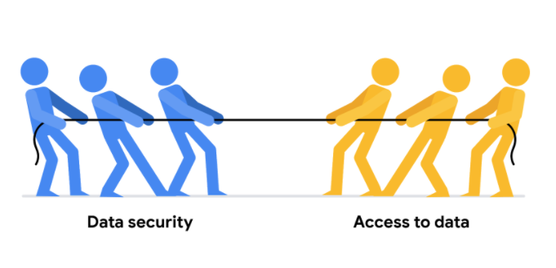

Luckily, there are a few security measures that can help companies do just that. The two we will talk about here are encryption and tokenization.

**Encryption** uses a unique algorithm to alter data and make it unusable by users and applications that don’t know the algorithm. This algorithm is saved as a “key” which can be used to reverse the encryption; so if you have the key, you can still use the data in its original form.

**Tokenization** replaces the data elements you want to protect with randomly generated data referred to as a “token.” The original data is stored in a separate location and mapped to the tokens. To access the complete original data, the user or application needs to have permission to use the tokenized data and the token mapping. This means that even if the tokenized data is hacked, the original data is still safe and secure in a separate location.

Encryption and tokenization are just some of the data security options out there. There are a lot of others, like using authentication devices for AI technology.

As a junior data analyst, you probably won’t be responsible for building out these systems. A lot of companies have entire teams dedicated to data security or hire third party companies that specialize in data security to create these systems. But it is important to know that all companies have a responsibility to keep their data secure, and to understand some of the potential systems your future employer might use.